Analysis Of The Task "Candy"

To begin with, let's consider the simplest solution to this problem, when a = b = c = 1. It is not difficult to see that in this case the values of x, y and z should be as equal as possible, i.e. x = y = z = n/3. If n is not divisible by 3, then some of these numbers should be rounded up, some - down.
To prove this statement, consider two cases: the first is when x = y = z = n/3, and the second is when x = n/3 + t, y = n/3 – t, z = n/3. In the first case xyz = (n³/27), in the second xyz = (n³/27) – t²n/3, which is less for any non-zero value of t.

In general, we can assume that ax, by, cz are close to n/3. To verify this, we first investigate this statement for a simpler problem: ax + by = n.

Consider the initial value 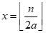и 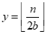, that is, x and y such that ax and by are close to n/2. Note, that 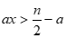 and 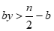. Therefore,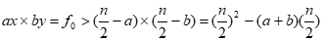.

Let's now try to take the values of x and y that differ from n/2 by t and investigate at which values of t the result can be better. We get 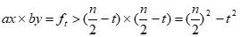. If 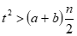, then this result is less than at the first values of x and y.

Let's consider at which values of t the result can be better. Let t = a×dx = b×dy и a ≥ b. Then from the previous inequality it turns out that interesting 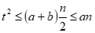, i.e.. Note, that dx ≤ b ≤ a. It turns out that dx³ ≤ n. So, the best result can only be when .

It remains now to generalize the idea for three variables. Note that for any two of the three unknowns, the same reasoning can be carried out, that is, ax and by cannot differ more than by the cubic root of n, and also the pair ax and cz and the pair by and cz cannot differ much.

With that said, the solution to the original problem will be as follows.

- We take as a first approximation 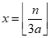, 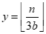и 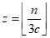.

2. Let's iterate through all permutations of a, b and c.
3. Iterate over x in the interval from 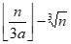to 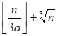
4. Iterate over y in the interval from 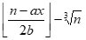to 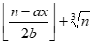
5. We get 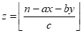 and check whether the product has become larger than the current one.

Such a solution has asymptotic complexity O(n^{2/3}). Note that the number of boxes of sweets, determined by the product of the dimensions of the box, can be on the order of 10²⁷, that is, exceed the maximum value of an integer 64-bit data type.

In order to avoid long arithmetic when comparing iterated options, instead of an inequality of the form use inequality . If the difference does not exceed 2⁶³, then the overflow inequality will be determined correctly. You can also use a real type with extended precision.

It should be noted that a partial solution based on iterating over all possible values of x and y and calculating z by the formula , it has an asymptotic complexity of O(n²) and is estimated from 40 points.

